Demo Lesson Plan
Unit 5 Reading for pleasure |  | Lesson 1
School |  | A.Sygay.
Teacher name: |  | Dimetova Matluba
Date:
Grade: 9 |  | Number present: | absent:
Lesson title | Language Focus. Future Continuous.
Learning objectives | 9.3.7.1 use appropriate subject-specific vocabulary and syntax to talk about an increased range of general and curricular topics  9.5.4.1 use with minimal or no support style and register appropriate to a growing variety of written genres on general and curricular topics;  9.6.10.1 use present continuous forms and past continuous, including a growing variety of passive forms, on a range of familiar general and curricular
Lesson objectives | Learners will be able to:  - Learn about using the future continuous.  -Use the future continuous to talk about what you’re doing in the future.
Value links | Creativity and Critical Thinking  Enhancing problem-solving and innovation, you understand the importance of creativity and critical thinking as tools to approach challenges with fresh perspectives and solutions.
Plan

Stages / Time | Teachers’ actions | Students’ actions | Assessment criteria | Resources
Beginning of the lesson  5 min | 1.Greeting.  Ask about the weather.  Warm-up Activity: "Time Travel Game"  Divide students into pairs or small groups. Ask them to imagine that they are time travelers who will visit the year 2040. Each pair/group should describe what they will be doing at that time.  Example:  "In 2040, I will be living on Mars. I will be working as a space engineer."  Purpose:  To develop speaking skills.  To introduce the future continuous tense in a fun and engaging way.  Lead – In  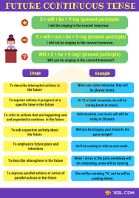  "What Will You Be Doing?" Ball Toss Game  Idea:  Start the lesson by tossing a soft ball to a student and asking them, "What will you be doing at this time tomorrow?" The student must answer using the future continuous tense before tossing the ball to another classmate.  Example:  Purpose:  Energizes the class and gets everyone involved.  Encourages quick thinking and speaking in the target tense. | The aim: To develop Ss speaking skills and create friendly atmosphere  Efficiency: By telling the wishes they show their appreciations .  Students express their ideas  Students share their imagined scenarios using the future continuous tense.  "I will be studying English at this time tomorrow." | At the organization moment T tries to award active Ss.  «The praise» method is used to evaluate Ss with phrases like:  “Good job!  Well done!” | 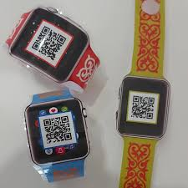    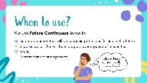  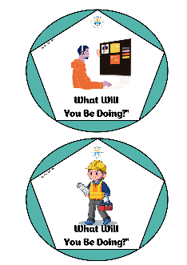
Middle of the lesson  Presentation part.  35 min | Ex:1 P:61  Read the sentences aloud with the class and ask students to identify the verbs.  Explain how the future continuous tense is formed (will + be + -ing).  Ask students to work individually to complete the rules.  Differentiation:  «Verbal support» method is used to help Students use new words in the text.  Ex: 2 P:61  Guide students in completing the text by filling in the blanks with the correct future continuous forms.  In a weaker class, allow students to work in pairs.  Check answers as a whole class.  Ex: 3 P:61  Read the instructions aloud.  Ask students to put the words in order to make sentences and questions in the future continuous tense.  Have students compare answers in pairs before checking as a class.  Ex: 4 P:61  Ask students to write sentences and questions using the future continuous tense.  Monitor their progress and provide feedback.  Ex: 5 P:61  Have students read a short dialogue and complete it using the future continuous form of the verbs provided.  Once completed, ask them to practice the dialogue in pairs.  Invite a few pairs to perform their dialogue for the class. | Students look at the sentences from the text on page 60 and the listening and complete the rules  ANSWERS:  1 is in progress  2 will, be  3 won’t  Students complete the sentences with will / won’t or be  ANSWERS:  1 will  2 be  3 will  4 be  5 be  6 will  Students put the words in order to make sentences and questions.  ANSWERS:  1 What will you be doing at 6 p.m. tomorrow?  2 The author will be visiting the bookshop on Friday to sign books.  3 We won’t be leaving early tomorrow morning. It’s the weekend.  4 Where will you be staying while you’re in London?  5 I won’t be staying at my grandparents’ house this summer.  Students write sentences and questions using the future continuous.  ANSWERS:  1 Philip Pullman will be signing his book in the hall after he  finishes his talk.  2 I will be working on my new book this evening.  3 At 9 p.m. this evening, we will be sitting on a train to Lake  Balqash.  4 Will you be playing basketball on Saturday morning?  5 When will the choir be giving its next concert?  6 Maria won’t be watching the football match this evening.  She has to go to a piano lesson.  Students complete the dialogue with the future  continuous and the words in the box.  ANSWERS:  2 will be sketching  3 will be developing  4 will be meeting  5 will, be drawing  6 (will you be) writing  7 will be doing  8 will be using | Descriptor:  - look at the sentences  - complete the rules  Descriptor:  - complete the sentences  - use will / won’t or be  Descriptor:  - put the words in order  - make sentences and questions.  Descriptor:  - write sentences and questions  - use the future continuous.  Descriptor:  - complete the dialogue  - use the future  continuous |   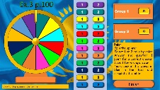  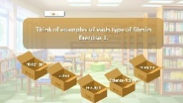  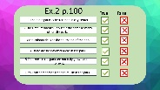
End of the lesson  5 min | Giving the hometask.  Ex: 1 P:41 wb  Self-reflection | Peer-assessment. Two stars and a wish.  You did a really good job on ...  I really like how you ...  Maybe you could ... | Students use their stickers to show their knowledge according to the lesson. | 