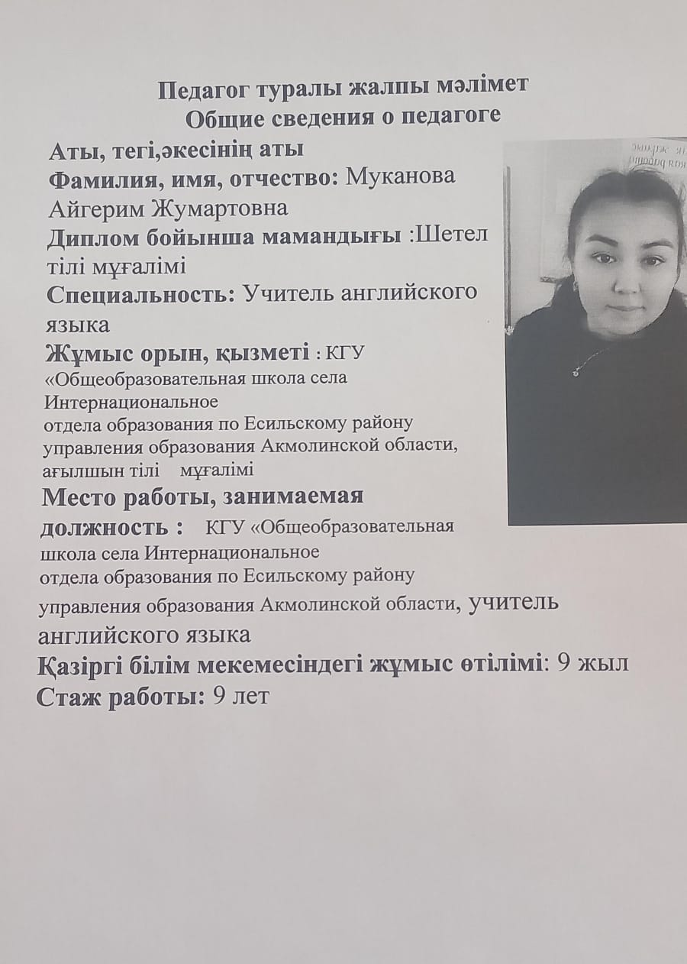

Theme ; The Modern Teacher: Role, Challenges, and New Approaches
подготовила: Муканова Айгерим Жумартовна

A modern teacher is not just an instructor standing at the blackboard, delivering knowledge from a textbook to students. In the age of globalization, digital technologies, and constant societal change, the role of the teacher has significantly expanded and transformed. The teacher of today is a mentor who helps not only with subject knowledge but also with personal development, the formation of moral values, and social adaptation of students.
The modern teacher fulfills several key roles. First, they act as a mediator between knowledge and students. Unlike the traditional approach, where the focus was solely on the transfer of information, today the emphasis is on developing critical thinking, creativity, and student autonomy. The teacher helps students develop the ability to learn, search for information, analyze, and solve problems.Secondly, the teacher plays a significant role in upbringing. Modern children are exposed to numerous information streams, contradictory norms, and behavioral models, and teachers are required to be not only educators but also mentors, ready to offer support in difficult situations. Teachers help students develop emotional intelligence, socialization skills, and the ability to interact with others. It is important that the teacher evaluates not just students’ knowledge but also takes into account their individual characteristics, interests, and needs.
Modern teachers face a number of new challenges. The technological revolution is changing the very process of education. The use of gadgets and online platforms has become the norm, and teachers must be ready to adapt their methods to these innovations. It’s important not only to use technology but also to teach students how to apply it properly, filter information, and critically assess it.Moreover, modern teachers often face the problem of overload. The contemporary educational system frequently sets high expectations for teachers, leading to professional burnout. Teachers must not only teach but also organize extracurricular activities, collaborate with parents, and deal with the emotional challenges of students. To be effective, teachers need support and continuous professional growth.
Modern pedagogical approaches include elements of personalized learning, where it is crucial to consider the interests of each student and create conditions for their self-realization. This approach positions the student as an active participant in the process, while the teacher acts as an organizer and facilitator, guiding and supporting, rather than merely dictating information.Additionally, modern teachers use innovative methods, such as project-based learning, game technologies, blended learning, and other forms that not only enhance intellectual abilities but also develop students' creative and practical skills. This is important in a world where many professions require non-standard approaches, flexibility, and the ability to work in uncertain conditions.

The modern teacher must be not only a professional but also a person who serves as an example for their students. They should be open to new ideas, cultivate empathy, respect for each student, and a commitment to self-development. Personal qualities such as tolerance, honesty, responsibility, and attention to detail are essential components of a teacher’s success.
The modern teacher is a multifaceted figure who plays a key role in shaping society. They do not only transmit knowledge but also help students become independent, responsible, and socially adaptable individuals. In a world of constant change, pedagogy demands flexibility, readiness for innovation, and professional development. It is essential that teachers not only teach but also inspire, support, and foster the best qualities in their students, which is the foundation for a successful future for society.

