School №24 - Short term plan: term 3

Lesson Title: “The Two Giants”
Unit 6: Reading for pleasure |  | Lesson 67
Teacher name: A.A. Yesmaganbetova

Date: 20-Feb-2024
Grade: 5 «___» |  | Number present: | absent:
Lesson title | The Two Giants
Learning objectives | 5.3.7.1 use appropriate subject-specific vocabulary to talk about a limited range of general topics;  5.4.5.1 deduce meaning from context in short texts on a limited range of familiar general and curricular topics.
Lesson objectives | Learners will be able to:  - to introduce the topic and stimulate interest in the text  - organize and compare supported narratives on a wide range of the general  and curricular topic
Value links | Perseverance – People who value perseverance will work through adversity and be determined to get a result. This is a great treat for employees and entrepreneurs alike.
Plan

Stages / Time | Teachers actions | Students actions | Assessment criteria | Resources
Beginning of the lesson  Warming-up    5 min.  7 min | Organization moment:  Greeting.  Ask about the date, day and weather.  The teacher sets the lesson objectives, letting students know what to anticipate from the lesson.  Warming up  Game Learning up  Revision of previous material – Irregular Verbs  https://learningapps.org/view6342089  or  QR Code   | The aim: To develop pupils speaking skills and create friendly atmosphere  Efficiency: By wishing each other they feel better and feel the support of others  Students of the class are listed.  Students' attention is drawn to the lesson.  •Learners go the board, find the irregular verbs with its translation | The teacher assesses learners for their ability.  “Good job!  Well done!”  Formative Assessment    Good job!  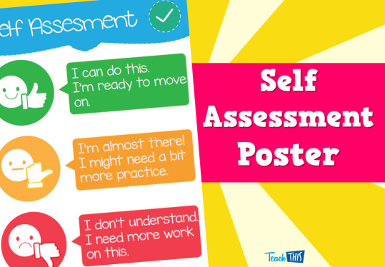  Self-assessment as well  Descriptor:  - remembers the irregular verbs | orally  Students are greeting each other and show their mood
Middle of the lesson  Presentation part.  28 min | Lead – In  Ex: 1 P: 82  Teacher switches on the extract and pupils try to guess what which the musical instrument is played.  Teacher shows slide and draw Ss' attention to the picture and text. Ask various Ss to read and translate. Ss answer the Teacher’s questions chorally or individually.  After watching the video Teacher elicit the Ss understanding  Ex: 3 P: 83  • Allow Ss mark the sentences T (true) or F (false).  Direct Ss to the Word List to look up the meanings of the words in the Check these words box.  Check Ss' answers. As an extension ask Ss to correct the false statements.  The game  Teacher divides Ss into two groups. They have two tasks.  Task 1. Ss match linking words to the pictures  Task 2. Ss put the text into the correct order  To sum up the lesson Teacher provides the test via Plickers App  Teacher will check Ss answers via QR Code  https://www.plickers.com/library  Conclusion during the lesson some tasks differentiated by outcomes of the students and by their abilities. | • learners guess the names of musical instruments.  • Learners watch the video. Listen and repeat. Answer the question.  ANSWERS  Students’ own answer  ANSWERS  1 Y  2 O  3 O  4 Y  5 Y  6 O  • Learners complete the sentences  ANSWERS  • Learners complete the task | Descriptor:  - listen and guess.  - read the text and answer the questions    self assessment  Differentiation: «Verbal support» method is used to help Ss use new words in the sentences.  Descriptor:  - match on the interactive board    self assessment  Descriptor:  - play and fulfil the task  The teacher assesses learners for their ability.  “Good job!  Well done!”  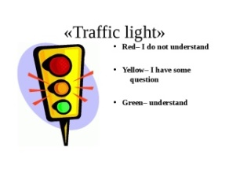self assessment | CD1  or  https://mp3party.net/music/7513813  Canva  presentation  ICT  YouTube  channel  https://www.youtube.com/watch?v=xzURVmZRFcw&ab_channel=ForEnglishLessons  Cards and pictures  Plickers Test
End of the lesson  5 min | FEEDBACK  Learners provide feedback on what they have learned at the lesson.  HOMETASK  Ex: 10 P: 83 | 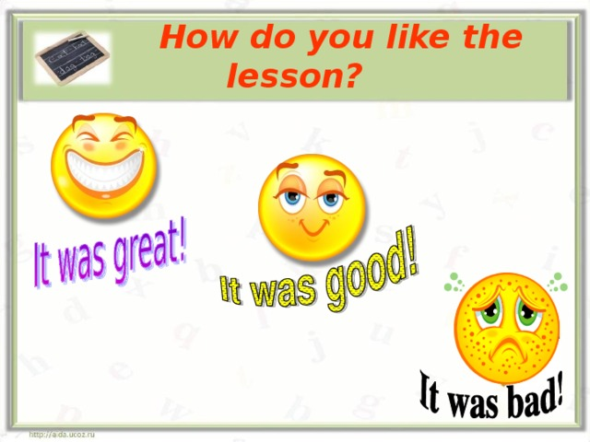 |  | Poster Success  

Cards for the Game
Task 1
FAST | FAST
WONDERFUL STEPPE MUSIC | WONDERFUL STEPPE MUSIC
DANGEROUS | DANGEROUS
TWO STRINGS | TWO STRINGS
STONE | STONE
ENORMOUS | ENORMOUS
LONG NECK | LONG NECK
WOODEN BODY | WOODEN BODY

Task 2
The Two Giants
Two giants lived in the Altai Mountains in Kazakhstan. They were brothers. The younger brother loved music and singing, so one day he made himself an instrument out of wood. He gave it a long neck and two strings. He played his new instrument all day and sang. It made him very happy.
The older brother didn’t like music. He wanted to be famous. He decided to build an enormous stone bridge across the big river. It was a fast and dangerous river and no one could cross it.
My bridge can make me famous, he thought. So he started to build.
__________________________________________________
It was hard work, but he was strong. He carried many heavy stones from the mountain to the river, but his younger brother didn’t help him. He didn’t want to be famous. He only wanted to play his instrument and sing.
The older brother became very angry.
You never help me! He shouted. You only play your silly music all day long.
___________________________________________________
He snatched the instrument from his brother’s hands and smashed it against a rock. He hit the rock to hard that you could see the instrument’s shape on the surface. The beautiful instrument broke. The younger brother was so sad that he never played music or sang again.
Years passed, until one day, some people found the shape on the rock. They used it to make a musical instrument. They called it a dombra and they used it to play the wonderful music of the steppe.

