Long term plan unit: 5 |  | School: Т.Berdiyarov
Date: |  | Teacher name: Aldeneyeva Aigul
Grade:1 |  | Number present: | Absent:
Theme of the lesson: Getting to School
Learning objectives (s) that this lesson is contributing to |  | 1.L4 recognise with support short basic questions about what something is  1.S1 make basic personal statements about people, objects and classroom routines  1.UE9 use common present simple forms [positive, negative and question] to give basic personal information
Lesson objectives |  | All learners will be able to: define short basic questions and make up statements about types of transport using common present simple forms to speak about how they get to school with lots of support;  Most learners will be able to: define short basic questions and make up statements about types of transport using common present simple forms to speak about how they get to school with some support;  Some learners will be able to: define short basic questions and make up statements about types of transport using common present simple forms to speak about how they get to school without support;
Assessment criteria |  | Define short basic questions about what something is with support  Make up basic personal statements about people, objects and classroom routines  Apply common present simple forms [positive, negative and question] to give basic personal information
Value links |  | Mangilik Yel. Patriotic act: 4th value: Economic growth based on industrialization and innovation
Cross curricular links |  | Kazakh, Russian
ICT skills |  | Whiteboard
Previous learning |  | -
Plan
Time | Planned activities |  |  | Resources
5 min  6 min  6 min  7 min  6 min  10 min | Classroom organisation (Whole class activity)  Learning and lesson objectives presentation  -Greeting.  -Dividing into three groups.  -Reviewing the previous lesson.  Flashcards (Whole class activity)  I will ask questions to find out their background knowledge.  Ask some questions.(About car, plane, bike, foot, bus.)  - What is it?  - Do you have it at home?  - Is it big?  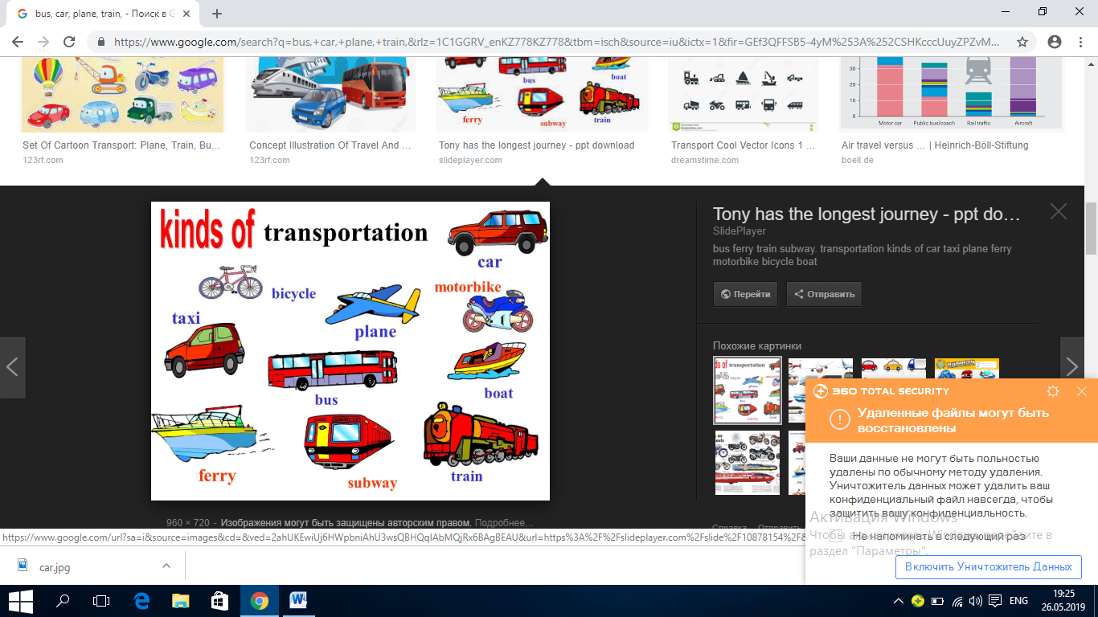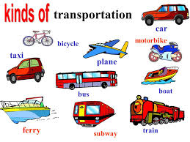  Differentiation by support: I will ask personal questions to less able learners.  Formative assessment: I’ll give some pictures (transport)  Slowly, Slowly (Whole class activity) I will show а picture, learners should say pictures’ names.  Differentiation by learning style: in this activity I ‘ll cover my audial and kinesthetic learners. They will learn transports names for several times.  Formative assessment: I’ll say : Good job! Well done! аnd etc.  Magic eyes (Whole class activity)  I will set several pictures on the board and ask learners to repeat the pictures’ names in a rhythmic way. I will take off one of the pictures each time and learners will name them even if they can not see them.  Differentiation by learning style: I will involve audial learners, because these learners learn when they listen to something.  Formative assessment:  Descriptor:  A learner :  - says names of transport given in a row;  What transport is this? (Pair work)  Learners watch the video and work with pairs. Ask learners to make sentences in positive, negative and question forms.  For example:  -Is it a car? -Yes, it is.  -Is it a bus? -No, It isn’t  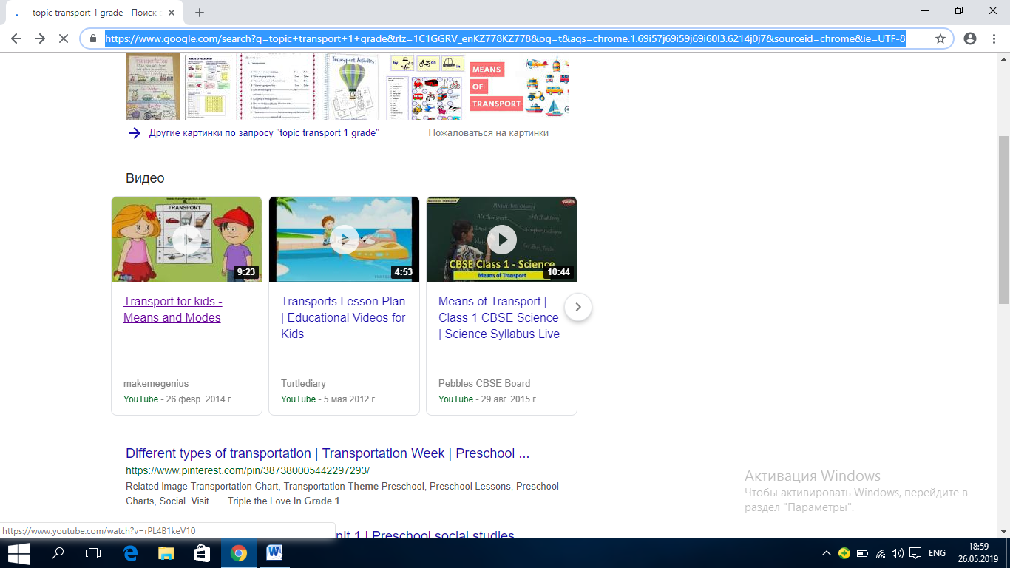  Differentiation by support: I’ll help learners to understand the meaning of the statements and how to make up sentences in positive, negative and question forms.  Formative assessment:  Descriptor:  A learner :  - names the transport;  - says the transport  Flashcard riddles (Individual work)  I will describe some of the transport and learners will find them according to the description.  - It is big.  - It is grey.  - What is it?  Differentiation by support: Less able learners work with teachers’ assistance. They will listen to the description and find the type of transport.  Formative assessment: I will assess by: Excellent, You are the best and etc. |  |  | https://www.google.com/search?q=bus,+car,+plane,+train,&rlz=1C1GGRV_enKZ778KZ778&tbm=isch&source=iu&ictx=1&fir=GEf3QFFSB5-4yM%253A%252CSHKcccUuyZPZvM%252C_&vet=1&usg=AI4_-kSraPdUsemns1CRdk8W-Oe94QoVlQ&sa=X&ved=2ahUKEwiptYyzorniAhUx2aYKHdihDBwQ9QEwB3oECAYQBA#imgrc=gEdaO5o127ma8M:&vet=1  https://www.google.com/search?q=bus,+car,+plane,+train,&rlz=1C1GGRV_enKZ778KZ778&tbm=isch&source=iu&ictx=1&fir=GEf3QFFSB5-4yM%253A%252CSHKcccUuyZPZvM%252C_&vet=1&usg=AI4_-kSraPdUsemns1CRdk8W-Oe94QoVlQ&sa=X&ved=2ahUKEwiptYyzorniAhUx2aYKHdihDBwQ9QEwB3oECAYQBA#imgrc=gEdaO5o127ma8M:&vet=1  https://www.google.com/search?q=bus,+car,+plane,+train,&rlz=1C1GGRV_enKZ778KZ778&tbm=isch&source=iu&ictx=1&fir=GEf3QFFSB5-4yM%253A%252CSHKcccUuyZPZvM%252C_&vet=1&usg=AI4_-kSraPdUsemns1CRdk8W-Oe94QoVlQ&sa=X&ved=2ahUKEwiptYyzorniAhUx2aYKHdihDBwQ9QEwB3oECAYQBA#imgrc=gEdaO5o127ma8M:&vet=1  https://www.youtube.com/watch?v=rPL4B1keV10  https://www.google.com/search?q=bus,+car,+plane,+train,&rlz=1C1GGRV_enKZ778KZ778&tbm=isch&source=iu&ictx=1&fir=GEf3QFFSB5-4yM%253A%252CSHKcccUuyZPZvM%252C_&vet=1&usg=AI4_-kSraPdUsemns1CRdk8W-Oe94QoVlQ&sa=X&ved=2ahUKEwiptYyzorniAhUx2aYKHdihDBwQ9QEwB3oECAYQBA#imgrc=gEdaO5o127ma8M:&vet=1
Additional information
Differentiation – how do you plan to give more support? How do you plan to challenge the more able learners? |  | Assessment – how are you planning to check learners’ learning? |  |  | Health and safety check
Flashcards: Differentiation by support: I will ask personal questions to less able learners.  Slowly, Slowly: Differentiation by learning style: in this activity I ‘ll cover my audial and kinesthetic learners. They will learn transports names for several times.  Magic eyes: Differentiation by learning style: I will involve audial learners, because these learners learn when they listen to something.  What transport is this?  Differentiation by support: I’ll help learners to understand the meaning of the statements and how to make up sentences in positive, negative and question forms.  Flashcard riddles:  Differentiation by support: Less able learners work with teachers’ assistance. They will listen to the description and find the type of transport. |  | Flashcards: Formative assessment: I’ll give some pictures (transport)  Slowly, Slowly: Formative assessment: I’ll say : Good job! Well done! аnd etc.  Magic eyes: Formative assessment:  Descriptor:  A learner :  - says names of transport given in a row;  What transport is this?  Formative assessment:  Descriptor:  A learner :  - names the transport;  - says the transport  Flashcard riddles:  Formative assessment: I will assess by: Excellent, You are the best and etc.
Reflection
Were the lesson objectives/learning objectives realistic?
Did the learners achieve the LO?
If not, why?
Did my planned differentiation work well?
Did I stick to timings?
What changes did I make from my plan and why?

Summary evaluation
What two things went really well (consider both teaching and learning)?

1:

2:
What two things would have improved the lesson (consider both teaching and learning)?

1:

2:

What have I learned from this lesson about the class or achievements/ difficulties of individuals that will inform my next lesson?

‘

