Short term plan
School named after K.Koshmambetov
Lesson 69
Term: III | VII. Fantasy world
Teacher’s name: | M.Auyelbekova
Date:
Grade: 5 B | Number present: | Number absent:
Theme of the lesson: | An article about two places.
Learning objectives(s)  that this lesson is contributing to | 5.L6 deduce meaning from context in short, supported talk on an increasing range of general and curricular topics;  5.S6 communicate meaning clearly at sentence level during, pair, group and whole class exchanges;  5.R1 understand the main points in a limited range of short simple texts on general and curricular topics.
Lesson objectives | By the end of the lesson, the students will be able:  to understand a text about two places, to describe the sights, using active vocabulary;  to recognize and use vocabulary to make up a story of description;  to express personal attitude toward a topic discussing a topic.
Lesson plan:
Stages of the lesson/ Time | Teacher’s activity | Student’s activity | Assessment | Resources/ materials
Organisation moment:  3 min.  Greeting | Good morning, dear pupils. How are you today?  Then to create a positive learning environment the teachers asks students to start the lesson giving each other compliments. | Expected student responses, modes of operation.  -Good morning/ Good afternoon. We are glad to see you. How are you? We had a very good time.   |  | Whiteboard
Warm up:  7 min. | A teacher writes a word: HOLLYWOOD on the board  and asks Sts. to say what they know about this place.  Hollywood is a neighborhood in the central region of Los Angeles, California. Its name has come to be a shorthand reference for the U.S. film industry. Many film studios such as Columbia Pictures, Walt Disney Studios, Paramount Pictures, Warner Bros., and Universal Pictures are located near or in Hollywood | Sts. give their own answers.  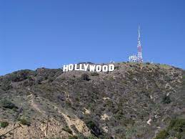  Hollywood is in Los Angeles.  There is a Hollywood in Ireland too.  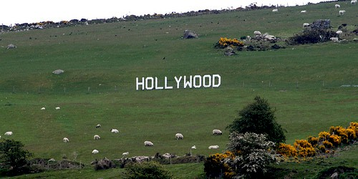 | Self – Assessment  Assessment criteria:  - Apply topic related vocabulary in speech appropriately arranging words and phrases into well-formed sentences.  - Identify facts and details in extended talks with little support.  Descriptor:  A learner:  - uses the topical vocabulary while talking about a news story.  chooses the right answers. | Whiteboard  Pictures
Main Activities  15 min. | A teacher asks Sts. to compare 2 pictures and describe them.  Listen to the text and fill in a table. Use active words:  quiet, famous, noisy, small.  A teacher divides class into 2 groups: Hollywood in the USA and Ireland. Groups read the stories and make a mind – map. Then they present the places.  Sts. also include questions from Ex.3 p.28.  A teacher asks Sts. to find opposites from two texts.  Do Ex.4 p.28. Read the words and name similar words in the Russian and Kazakh languages.  Ex.5 p.22(workbook) | Sts. look at the pictures and describe them, then fill in a table.  Hollywood in the USA Hollywood in Ireland  City, 1910 village  American film industry. “Holy Wood”  30 minutes from Dublin  Sts. choose right words to the places.  Groups prepare presentations.  Sts. find opposites from 2 texts. This task is done in pairs.  City – village  Noisy – quiet  Big - small  Sts. do the task in pairs: park – парк – саябақ  Museum – музей – мұражай. | Pair– Assessment  Assessment criteria:  1. Demonstrate an ability to organize and express ideas clearly;  2.Apply topic related vocabulary in speech appropriately arranging words and phrases into well-formed sentences.  Descriptor. A learner:  - uses appropriate subject-specific vocabulary while speaking.  Observe learners when participating in use of English activities.  Record what they considered they had learned from the lesson. Could they express what they had learned about content and language? Could they express which skills they had developed?  Formative assessment is held through observation/monitoring.  Pair – Assessment  Recognise the content of an extended conversation using some supporting information. | Worksheet  Student’s Book “English Plus 5. Kazakhstan edition”. (Oxford University Press)  p.28  CD.1.32  St. Book p. 28  Workbook p.22
Physical Training  5 min. | A teacher asks one St. to watch a video and hold a physical training minute. | Sts. listen to the song and watch with the main characters on the screen. |  | Music
10 min. | A teacher asks Sts. to read 2 texts and compare the articles: The Pencil Museum – The British Museum. Do Ex.2 – 4 p.22 | Sts. do the exercises in pairs: they read the texts individually and make some notes or mind – maps. | Group - Assessment  Apply the active vocabulary and grammar in practice.  Recognise the content of an extended conversation using some supporting information. | Workbook  .
The end of the lesson  5 min. | Teacher gives a homework and comment the work of Sts. The lesson is going to its end. I think, you have got much useful information today  Home Assignment:  St. Book  Ex. 5 p.28(w). | 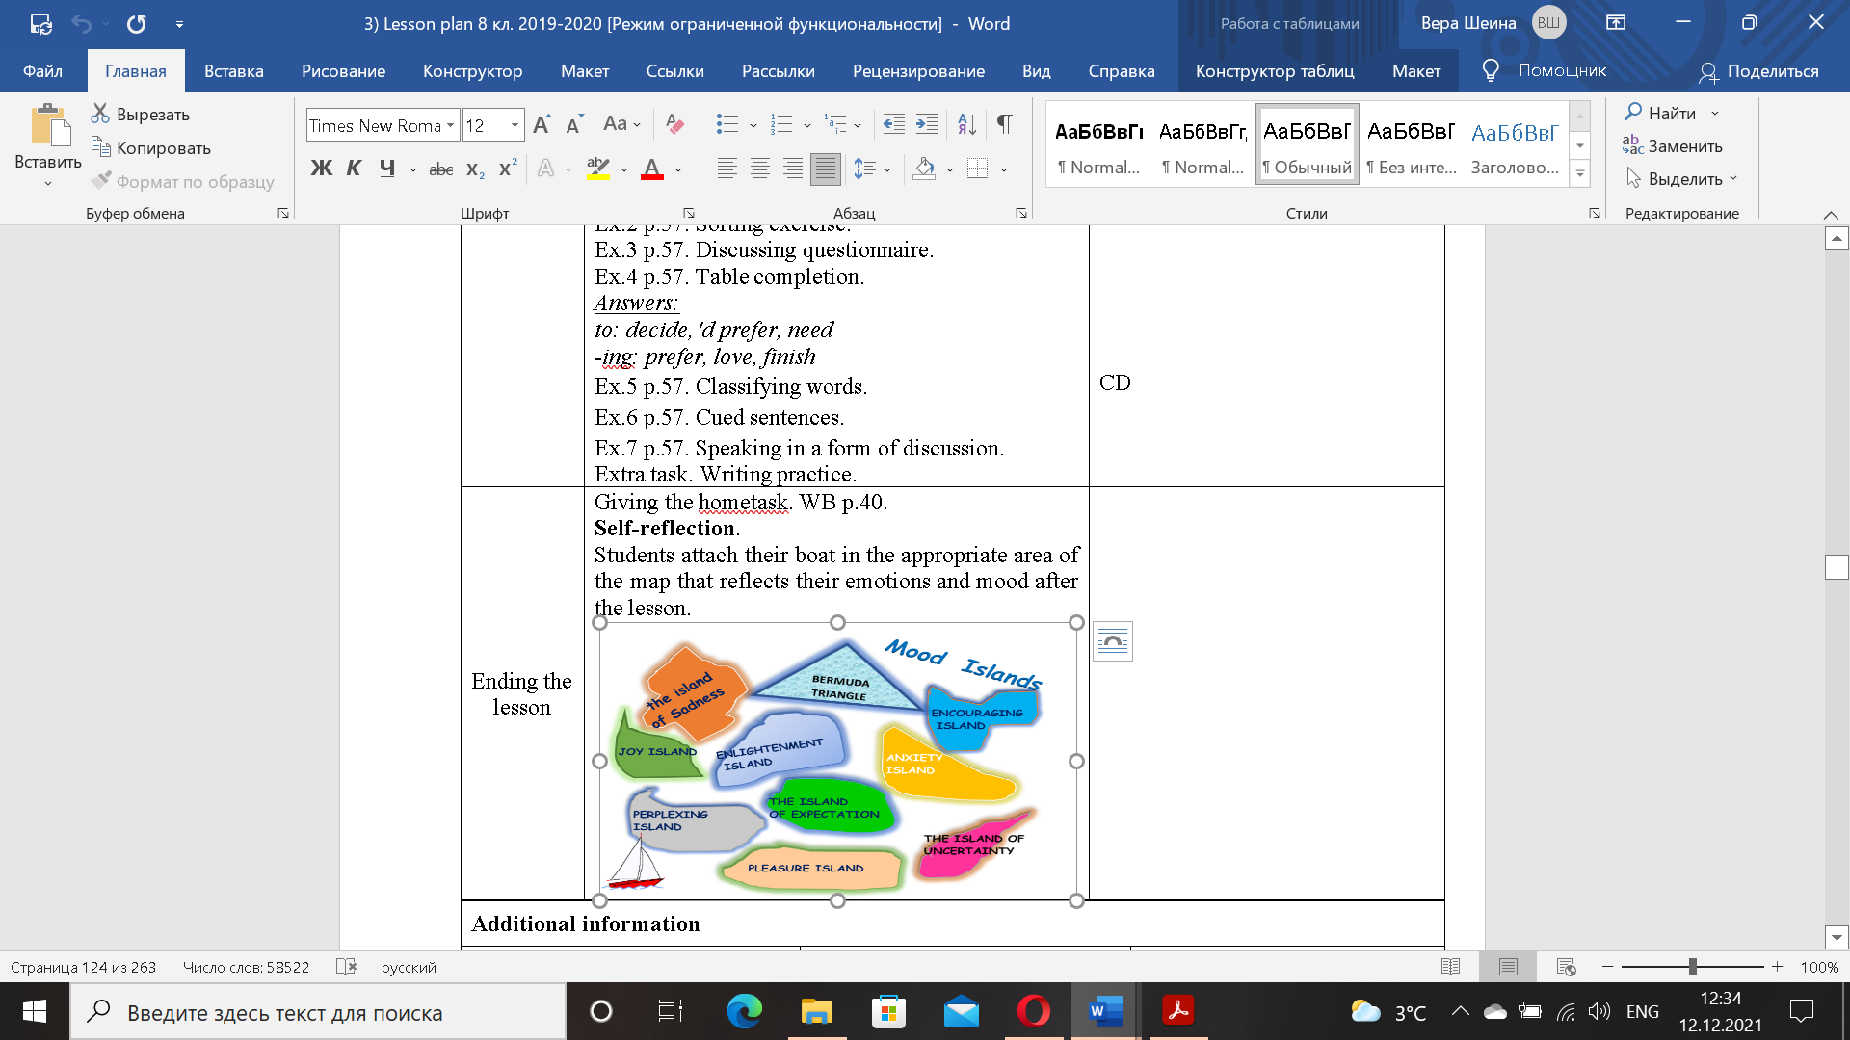  SS write their homework for the next lesson. | Self-reflection.  Students attach their boat in the appropriate area of the map that reflects their emotions and mood after the lesson. | Whiteboard

