**Lesson Plan**

|  |  |
| --- | --- |
| Unit 3:Our countryside | Kaskelen gymnasium school |
| Teacher’s name: | Keneskhan Dana |
| Date: |  |
| Grade: 6 | Number present: absent: |
| Theme of the lesson: | Animals |
| Learning objectives(s) that this lesson is contributing to: | 6.2.2.1 understand with little or no support most specific information in extended talk on a wide range of general and curricular topics;  6.1.1.1 use speaking and listening skills to solve problems creatively and cooperatively in groups ;  6.3.2.1 ask more complex questions to get information about a growing range of general topics and some curricular topics; |
| Lessonobjectives: | **Learners will be able to:**  -Identify the reasons about endangered animals  - make the “Venn diagram” about animals to solve their problems in groups  -talk about animals in red list  **For students with individual needs (low achiever students)**  Speak about animals;  Answer the simple questions; |
| Level of thinking skills: | Knowledge and comprehension  Higher order thinking skills |

**Plan:**

|  |  |  |  |
| --- | --- | --- | --- |
| **Part of the lesson/Time** | **Suggested tasks, forms ,activities and methods of teaching** | **Teaching notes** | **Resources** |
| **5 min.**  **5 min** | **Organization moment**  **Brainstorming**  **Method “Picture associations”**  **Scaffolding “Modeling”** | **Greeting. T-Ss** Teacher greets the students Checks students’ readiness for the lesson.  The teacher shows the pictures of animals and students guess what our new lesson will be about?  **Differentiation:** High achiever will give some information about animals. Low achiever students say the names of animals | Pictures |
| **5 min.**      Pair work  **7 min**  *Group work*  ***7 min***  *5 min*    ***6 min*** | **Listening**  **Pre – listening task**  **“Predicting strategy”**    **Scaffolding “Modeling”**    **While–listening**  **“Boolean”**  **strategy**  **Method “Gap filling”**  **The method “Venn diagram”**  **“Brainy strategy”**  **Functional Literacy**  Critical thinking  **Task 4.Post-listening task.**  **Concept checking questions**  Teacher asks CCQ questions in order to know students’ level of understanding the target language  **Functional Literacy Focus:**  Speaking and Constructive Expressions  **Speaking.**  **Method “Mind map”**    Small group discussion | Teacher shows pictures to students and asks what do they see  Teacher’s questions:  How many animals do you see?  Where do they live?  What do they eat?  Free vector animals big set  **Differentiation:** High achiever will answer all the questions. Low achiever students will say the names of animals and their colors  **Scaffolding “Modeling”**  Teacher gives distinctly examples of what is essential of them  Teacher helps to focus their attention on the listening text and guide the development of their comprehension of it. You will listen to the audio three times. Listen and fill the gaps with pairs.  Keywords:( sharks, species,  meat, different, animals, plants,rays,fins)  **Differentiation:**  High achiever students will fill the gaps by themselves. Low achiever students will say the animals name that they hear  **Scaffolding** to support all students be successful with their task low achieving students just say the animals names, while high achieving students fill the gaps by themselves  Teacher explains how to complete “Venn diagram” and writes useful words on the board. Students complete the diagram in a group dividing into two groups. Ss write species of sharks, species of fish and in the middle of the diagram they write Why people hunted for?  **Differentiation:**  High achiever students will complete the diagram. Low achiever students will complete the names of animals;  Teacher ask the questions. With the help of this task students could allocate and understand information. The teacher disposes a number to each students (for ex: 1,2,3) around the class  1.Do you like fishing?  2.What kind of other endangered animals do you know?  3. What kind of animals endangered in your country?  4.Is hunting popular in your country?  **Differentiation by learning environment**  The teacher adds strong able students to the students with individual needs.  Teacher divides students into two groups. Each group students make a list of animals in red list.  **Differentiation:**  High achiever students will make maps about animals in red list. Low achiever students will find animals in red list from the internet | Pictures and worksheet  https://breakingnewsenglish.com/1908/190827-endangered-species-5l.html  Worksheet  Worksheet  Mind map |
| **End of the lesson.**  Individual work  **5 min** | Teacher allocates “Leaves of the daisy” to students  **Home task:** Write about endangered animals in KZ | Students complete the leaves, stick on the board and make daisy  While students are completing the chart, teacher checks the students answers | Worksheet |

**Appendix 1**

**Brainstorming**

[**https://www.9news.com.au/world/animals-about-to-go-extinct/280c9546-c1c1-44e4-b336-3caf88988096**](https://www.9news.com.au/world/animals-about-to-go-extinct/280c9546-c1c1-44e4-b336-3caf88988096)

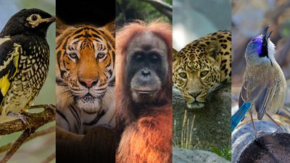

**Appendix 2**

[**https://www.freepik.com/free-vector/animals-big-set_4187188.htm#query=animals&position=29&from_view=keyword&track=sph**](https://www.freepik.com/free-vector/animals-big-set_4187188.htm#query=animals&position=29&from_view=keyword&track=sph)

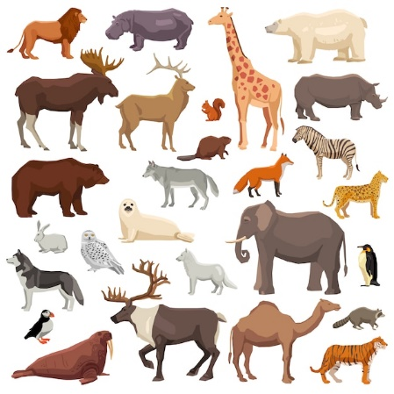

**Appendix 3**

**Fill the gaps**

Listen and fill the gaps with pairs.

<https://breakingnewsenglish.com/1908/190827-endangered-species-5l.html>

**Keywords: sharks, species,meat, different, animals, plants, rays, fins**

There is agreement on protecting 18 threatened ____ of ___ and ___. The Convention on International Trade in Endangered Species (CITES) agreed to give greater protection for the marine creatures from commercial fishing. Many of the threatened species are hunted for their ___ and ___. Some of the protected species include the world's fastest shark (the mako shark), wedgefishes and guitarfishes. The Wildlife Conservation Society said: "Sharks are vulnerable....Momentum is clearly building to ensure that these species...continue to be around for future generations."

CITES is an international treaty established in 1973 signed by 182 ____ states to protect endangered ____ and ____. The focus of the weekend meeting was on protecting sharks. The number of sharks killed each year by commercial fishing is estimated at 100 million. A conservation group said this could be as high as 273 million. Forty countries disagreed that the mako shark was in danger because there was not enough evidence to show it was disappearing as a result of fishing. The global shark fin market is thought to be worth over $1.2 billion.

Answers:

1) species

2 )sharks

3) rays

4) meat

5) fins

6) different

7) animals

8) plants

**Appendix 4**

**The method “Venn diagram”**

[**https://www.indeed.com/career-advice/career-development/venn-diagram**](https://www.indeed.com/career-advice/career-development/venn-diagram)

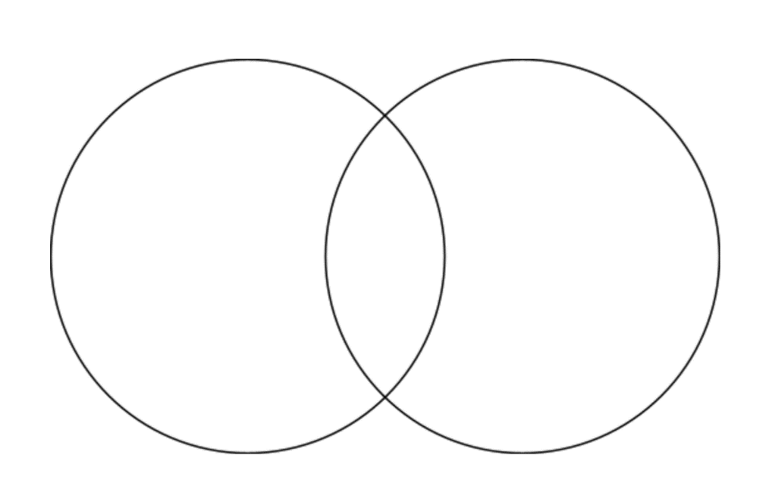

**Appendix 5**

**Concept checking questions**

1.Do you like fishing?

2.What kind of other endangered animals do you know?

3. What kind of animals endangered in your country?

4.Is hunting popular in your country?

**Appendix 6**

[**https://www.twinkl.co.uk/teaching-wiki/mind-map**](https://www.twinkl.co.uk/teaching-wiki/mind-map)

