Short term plan: term 3

Unit 5: Hot and Cold |  | Lesson 38
Teacher name: |  | Abdullaeva Sandugash

Date:
Grade: 4 |  | Number present: | absent:
Lesson title | Time for CLIL: snow and ice
Learning objectives | 4.2.8. 1 express basic likes and dislikes, recount short, basic stories and events on a limited range of general and some curricular topics  4.5.14.1 use prepositions of location, position and direction: at, in, on, behind, between, in front of, near, next to, opposite, above, up, down, on the right, on the left, use prepositions of time : in, on, at, before, after, use with/without to indicate accompaniment with for instrument and for to indicate recipient;
Lesson objectives | Learners will be able to:  - To explore other subject areas (Geography)  - to talk about snow and ice.
Value links | Generosity – This may be a core value of yours if you cherish people who will give their time and resources to people in need. You may consider yourself to be a generous person if you find joy and meaning in giving to others.
Plan

Stages / Time | Teachers actions | Students actions | Assessment criteria | Resources
Beginning of the lesson  Warming-up    3 min  Pre-learning  «Brainstorming» method  7 min. | Organization moment :  1.Greeting.  Ask about the weather.  The teacher sets the lesson objectives, letting students know what to anticipate from the lesson.  Warming up  Where are you from?  How old are you?  What color is it?  How many students are there in class?  What day of the week today?  Revise the language of the previous lesson.  Lead – In   | The aim: To develop pupils speaking skills and create friendly atmosphere  Efficiency: By wishing each other they feel better and feel the support of others  Students of the class are listed.  Students' attention is drawn to the lesson.  Determines the topic and purpose of the lesson  • Learners talk about favourite dayprevious lesson vocabulary  Students say different words from the picture and count one to hundred | The teacher to assess learners for their ability.  “Good job!  Well done!”  Formative Assessment    Good job!  Descriptor:  - talk about favourite day  Total: 1 point  Assessment criteria  - Learners have met the learning objectives if they can talk about snow and ice | Pictures  worksheet  Student’s book
Middle of the lesson  Presentation part.  30 min | Ex:26 P:78  • Say and write on the board snow and ice. Have a brief class discussion. Read aloud the words and elicit/explain any unknown vocabulary. Explain the activity. Allow the pupils some time to complete it. Check their answers.  Ex: 27 P: 78  • Refer the pupils to the pictures, one at a time, and mave a class discussion. Play the CD. The pupils listen and follow in their books.  Ex: 28 P: 79  • Explain the activity. Allow the pupils some time to read The text again silently and correct the sentences  Ex: 28 P: 79  • Explain the activity. Go through the text and elicit/explain any unknown words. Allow the pupils some time to complete the activity. Check their answers.  Conclusion during the lesson some tasks differentiated by outcomes of the students and by their abilities. | Pupils choose and write on the igloo the words that have to do with snow and ice.  ANSWERS  Scarf, snowflake, penguin, winter, ice crystal      Pupils listen and read  ANSWERS  Students own answer  Pupils read again. Correct the sentences  ANSWERS  2 ice/snow  3 volcano  4 blue whales  5 February  Pupils read, choose and complete.  ANSWERS  2 snowflakes  3 200  4 different  5 largest | Descriptor:  - write on the igloo the words  - check their answers  Total: 2 point    Self assessment  Descriptor:  - listen and read  Total: 2 point  Descriptor:  - read again  - correct the sentences  Total: 2 point  Descriptor:  - read, choose and complete.  Total: 3 point  -Make CCQ questions Yes / No  Total: 10 point |   Card  Worksheet  Students book
End of the lesson  5 min | FEEDBACK  Learners provide feedback on what they have learned at the lesson.  Ex:  Home task: | 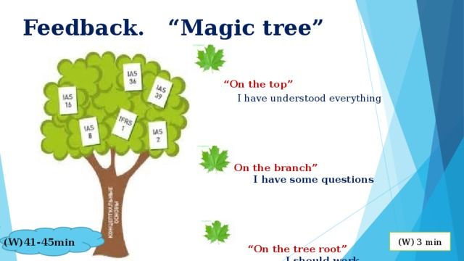 |  | Poster Success  

