Lesson plan
Unit:6 |  | School: B.Momyshuly
Date: 21.12.2023 |  | Teacher's name: A.Nurmetova
Class:5 G |  | Number present: 14 |  | Number absent:
Theme of the lesson: |  | I can talk about famous Kazakh artists.
Learning objectives(s) that this lesson is contributing to |  | 5.4.3.1 understand the detail of an argument on a limited range of familiar general and curricular topics;  5.1.3.1 respect differing points of view;
Lesson objectives to: |  | -read the text and answer the questions  -discuss about famous persons.
The course of the lesson.
Planned timings | Teacher's actions |  | Pupil`s actions |  | Assessment | Resources
Greeting.  Organizationmoment.  1 min. | Good morning, dear students. I’m glad to see you.  - How are you today?  - What is the weather today?  - What date\day is it today?  To create a friendly atmosphere in the classroom, students should stand in a circle, give each other a dodecahedron and say some wishes or warm words. I wish you a dodecahedron |  | The students greet the teacher.  Good morning, good morning to you,  We are glad to see you too.    How are you?  It is sunny/ cold/ hot.  By telling the wishes, they show their appreciations.  Students of the class are listed.  -I am brave  -I am smart  -I am important |  | Verbal assessment | Whiteboard    
 | Check the home task  Teacher check the home task by method  “Picker wheel” |  | Pupils check the home task |  | 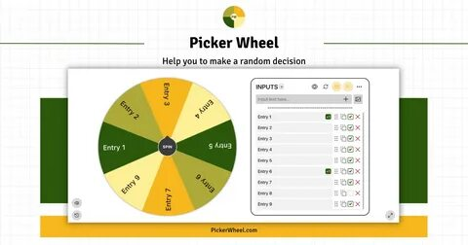 | https://pickerwheel.com/
2 min  2 min | Teacher ask students look at the Active board and spins the wheel. It divides class into 2 groups online.  1st group –  2nd group –  The teacher asks the students to look at the blackboard and watch a video  - What did you see in the video?  - What about this video?  - How do you think what is our theme?  The teacher sets the lesson objectives, letting students know what to anticipate from the lesson. |  | Students divide into 2 groups by online and take their places  Students watch the video and answer the questions |  |  | http://castlots.org/razdelit-na-gruppy/  https://youtu.be/0AFuG6RkfSI?si=uK_ClTHjxPPNr-kG
Pre -reading  Main part of the lesson  2 min | Pre-reading  Teacher elicits students’ knowledge about famous persons  Task1. Look at the pictures and answer the questions. Discussion  -Do you know these people?  -Who are they?  -What are they famous for?  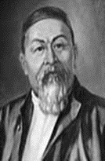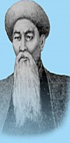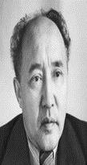 |  | Students look at the photos and try to answer more as they can in 1 minute |  | Descriptor:  A learner  - looks at the pictures;  - reads more words  - pronounces the words correctly  -answer the questions | Whiteboard  PPT
 | Teacher introduce students with new words  Neighbor[ˈneɪbə]Көрші  Author [ˈɔːθə]Автор  Translate[trænsˈleɪt]Аударма  Female[ˈfiːmeɪl]Әйел  Director[d(a)ɪˈrektə]Директор  Opera|ˈɒp(ə)rə|опера  Poor[pʊə]Кедей  Creative[krɪˈeɪtɪv]Шығармашылық  Government[ˈgʌv(ə)mənt]Үкімет  Renamed[riːˈneɪmd]Атауы өзгертілді  Arts[ɑːts]Өнер  Professional |prəˈfeʃənl| кәсіби  Nomads |ˈnoʊmæd| көшпелі халық Composer |kəmˈpoʊzər| композитор |  | Students write the words correctly and work with translation. |  | Descriptor:  A learner  -writes new words correctly | Active board
Middle of the lesson  10 min | While reading  Board journal" method  "Board journal" is a general term that includes various methods of teaching to write down one's thoughts while studying a topic. "Board log" is simply used before reading the text and after familiarizing with the reading material. Students write answers to the following questions:  Text.I can talk about famous Kazakh artists.  What do I know about this topic? What do I know? What news did I learn from the text? |  | Students work in groups. In the first column of the table, write what I know and what I don't know about the chosen topic. And in the second column, he writes what news he learned from the text. |  | Descriptor:  A learner  -work in groups  - Reads and understands the meaning of the text.  - Identifies specific information and details from the text.  - Discusses about it in  Formative assessment | White board  PPT  English plus p 76  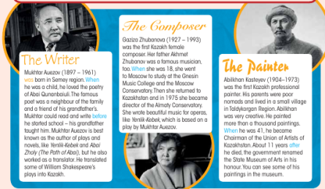
 | Teacher ask students to read and listen to the texts and complete the sentences with the names of the people by method of “Who is quicker?”  INDIVIDUAL WORK  WRITING  “WHO IS QUICKER? METHOD  - _____ was director of the Almaty  Conservatory.  - ____ and her father ___ were famous musicians  - _____ was very creative.  - ____ ’s parents were nomads.  - ___was a writer and a translator. |  | Students work individually, listen to the texts and complete the sentences with the names of the people by method of “Who is quicker?” |  | Descriptor:  A learner  -Work individually  -read the text  -listen to the texts  -complete the sentences  Students evaluate each other by emotion fans   | Whiteboard  PPT  English plus p 76  Exercise 1  https://youtu.be/FWGGsTRbj88?si=2XcvM7QKRtslYrcL
 | Rule:  Teacher explain the rule to the students.  The past simple forms of be are is / was (for I, he, she and it) and were (for you, we and they).  2. The past simple form of all other verbs is the same / different for all persons.  3. We form the past simple of most verbs by  adding -s / -ed.  4. Some verbs are irregular, for example, can, teach, go, become and write / paint |  | Students listen to the teacher’s explanation and say their opinion about rule |  | Good job! | Whiteboard  PPT  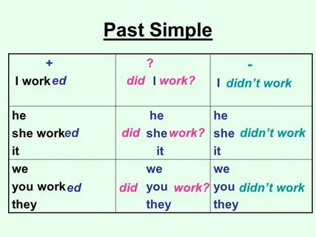
 | Teacher asks pupils to work individually and gave them unusual task. Each pupil takes one cards from the pigeons and complete the sentences with the past simple forms of the verbs in brackets.  INDIVIDUAL WORK  SPEAKING  PIGEONS METHOD  1.Abilkhan Kasteyev painted The Portrait of Zhambyl and Young Abai.  2.Mukhtar Auezov wrote Korgansyzdyn kuni in 1921.  3.Gaziza Zhubanova became a professor in 1978.  4.Abai Qunanbaiuli translated poems by Pushkin, Byron and Lermontov.  5.Magzhan Jumabayev and Gabit Musrepov were famous writers. |  | Students work individually, each pupil takes one cards from the pigeons andcomplete the sentences with the past simple forms of the verbs in brackets. |  | Descriptor:  A learner  -work individually  - takes one cards from the pigeons  -complete the sentences | Whiteboard  PPT  English plus p 76  Exercise 4  
 | Teacher ask students to describe five famous persons from Kazakhstan.  GROUP WORK  SPEAKING  - Abai Kunanbaev — a great Kazakh poet, who translated into his native tong verses by Pushkin, Lermontov, Goethe, Shiller, Bairon and Mitskevich.  - Mukhtar Auezov was: - a writer - a scientist-educator - one of the founders of Kazakh Soviet Literature - a famous public figure. |  | Students work in group and describe five famous persons from Kazakhstan. |  | Descriptor:  A learner  -Work in groups  -describe the Kazakfamous persons. | Whiteboard  PPT  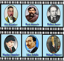  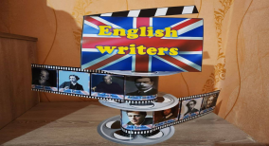
Physical training exercise –  3 min | A break for physical activity.  Teacher plays the video with physical exercises |  | Students watch and do physical exercises. |  |  | Music  https://www.youtube.com/watch?v=ZmJEhpBFKEY
 | Teacher ask students to look at the active board and play an online game. They should choose correct answer looking to photos. Students play this game in groups |  | Students play online games. They press the start button and choose the correct option |  | Descriptor:  A learner  - Works in groups  - chooses the correct option | Whiteboard  PPT  https://wordwall.net/ru/resource/25997841  Extra task  https://wordwall.net/resource/38174589
5 min | Teacher asks students to work in pairs and find hidden words in 3 minutes  PAIR WORK  SPEAKING  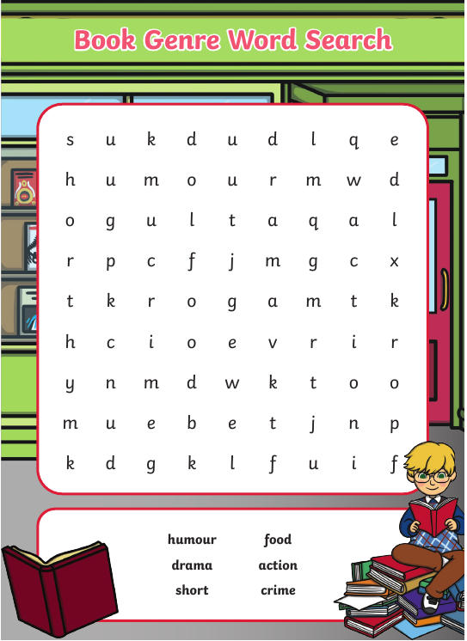 |  | Students work in pairs and find hidden wordsin 3 minutes |  | Descriptor:  A learner  -works in pairs  - find hidden words | Active board  PPT  Worksheet
The end of the lesson  3 min. | Teacher gives a homework and comment the work of Sts.  Home Assignment:  Reflection  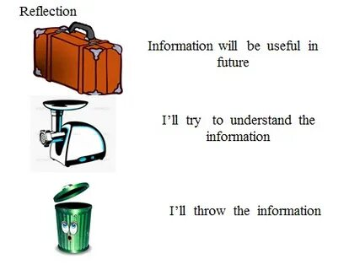 |  | Pupils write their homework for the next lesson.  Pupils. give a mark to themselves for working at the lesson.  Students think critically, exploring, developing, evaluating and making choices about their own and others’ ideas. |  | Pupils evaluate themselves using evaluation lists.  Reflection.  Self- Assessment. | Whiteboard  PPT

