LESSON PLAN
Title of the lesson
Theme of the module, subject |  |  | Stress and Fear
Teacher |  |  | Berikbol A.B.
Date
Learning outcomes |  |  | Understand specific information detail in texts on a growing range of familiar general and curricular topics, including some extended texts  Understand the main points in unsupported extended talk on a wide range of general and curricular topics  Give an opinion at discourse level on a range of general and curricular topics
Assessment criteria |  |  | Learners will be able to:  define different types of phobia  find the reasons of the appearance of phobia  suggest some life hacks how to overcomes some phobia
Level of thinking skills |  |  | Knowledge and comprehension Higher order thinking skills(HOTS)
Recourses and handouts
Time | Tasks, activities,  methods,  classroom arrangement,  forms, techniques |  | Teaching notes, classroom management |  | Recources
Leed-in 10 min  Reading  20min  Listening 30min  Speaking 20min | Warm-up  Strategy  “The wish flower”  Brainstorming ideas with the class using the pictures  Who am I?  Each person gets about 20 yes/ no questions to find out what is it?  What were you afraid of as a child?  (for low achieved students)  How do you talk about fears?  (for high achieved)  Understand specific information detail in texts on a growing range of familiar general and curricular topics, including some extended texts  I demonstrate the pictures associated with the topic phobia and ask their phobia  Pre-reading stage  Context based approach  Predicting strategy  Scaffolding: To support students understanding by different learning with Graphic Organizers  Differentiation strategy:  While-reading stage  Scanning  Text-based approach  Post- reading stage  Group-work  Discussion  Functional Literacy: develop communities  Involving all students methods: pair work  Understand the main points in unsupported extended talk on a wide range of general and curricular topics  Pre-listening stage  Mind Map  Strategy  While-listening stage  Look at the names of four phobias.  Fill them to explanations.(for low –achievers)  Filling the worksheets for high achiever  Scaffolding strategy:  Post-listening stage  CCQ  Targeted questions that help us to identify if the students understood the target material  give an opinion at discourse level on a range of general and curricular topics  Discussion  Collaborative approach  Speaking activity  Functional Literacy Focus: Speaking and Creative Expression  Involving All Students Method:  Guided Brainstorming  Small Group Discussion  Presentation and Feedback  “Traffic light”  method is used to find out was the lesson clear or not. Use the stickers |  | -Teacher greets students and st  During the lesson I follow the classroom management strategy  “The wish flower”  Method helps to start the lesson with good wishes to each other.  By wishing each other they feel better and feel the support of others.  They predict what the text will be about and more able learners write their predictions    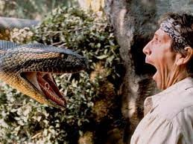  Matching  1.Cynophobia a)Fear of flying  arachnophobia b)Fear of dogs  Aerophobia c)Fear of spiders  Ophidiophobia d)Fear of snakes  1b 2c 3 a 4 d  Differentiation:  Low achieved students will be told about childhood phobias. Achievers will be told about childhood phobias and types of phobias and describe them.  It’s a fast reading technique. My students look for specific information in the text.  Unknown vocabulary list for struggling Ss  Cooperation and help in group  Timely help/observing  Active learning through collaboration  Clear /short instructions  There are 14 students. Divided into 2 groups.  1 group-What is the most common phobia?  2 group-How do phobias develop?  To create a mind map for creativity purposes, write down the problem you’re trying to solve .  To expand on this problem by surrounding it with terms that better describe what you need.  Draw a mind map.  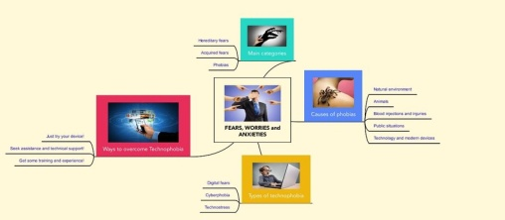  Questions of mind Map  -How many things can you see that some people have a phobia of?  When did start?  How does affect your life?  Listening and matching . They’ll know phobias and words related to fear.  1 2 3  What is he/she afraid of  When did it start?  How does it affect  https://www.youtube.com/watch?si=mw3OraP1_jJCLEL3&v=Tzbnyhcl4Qw&feature=y  youtu.be  Low-achievers will be fill the chart and talking about it. Achievers will be fill the chart and talking about reasons of appearance.  Students listen again and answer questions  Low- achiever learners should given more time than high –achieving learners and in intensive type of listening they perform yes/no question tasks. High achieving learners are expected to response CCQ in sentences.  -after listening students answer CCQ questions to find out the reasons of appearance the phobia  Which person do you think is most affected by their phobia?  Which of the phobias in this lesson do you think is the most irrational?  3 Which do you think makes the sufferers’ lives most complicated?  4)Are phobias easy to overcome?  5)What are some ways life hacks overcome of phobia?  Give them different wild animals and ask them to divide into 3 groups  I-spiders  II-dogs  III-snakes  Prepare their posters associated with the suggest some life hacks how to overcomes some phobia in their life and each group defend it.  Students use their stickers to show their knowledge according to the lesson.  Green-I understood  Yellow-I have some questions  Red- need a help  To know how many students got the theme. Students can use colors to show how much do they remember.  Differentiation:  “Conclusion” method is used to finish the lesson

